B.M.S Institute of Technology

Avalahalli, Yelahanka, Bangalore-64

Smart Grid Compatible Control of Appliances using Internet Protocol aided by Smart Occupancy Sensor and an Application on a Mobile Platform

**Under Guidance of:**

By:

**Mr. H.D. Kattimani** Sarath Vadakkepat

*Associate Professor* Prahlad Suresh

Prachet Verma

Abstract

Home automation is a well known term in today’s world, but the extent of automation is debatable. The people of this world are in constant effort to bring new technology to their fingertips, change and modify the existing technology to meet the demands and to salvage our thirst for exuberant luxury.

At the outset, Home Automation is loosely defined as the process of being able to control your home, to be precise , control is imparted particularly and only to the appliances present in a typical house. Home automation has been previously tested and proved with technologies pertaining to Radio Frequency, Infra Red etc. The aforementioned technologies are only used for sending a signal, to be precise, an active control signal to the control unit. This technology has stood the test of time and it’s time for the technology to rest as new technology is born every minute.

Technology is analogous to time and adhere very closely to Einstein’s Special Theory of Relativity, it never stops, never measured accurately. With the penetration of phones to this world, it affected the life of millions by changing their way of living. Time progressed so did technology, giving rise to a revolutionary change in the world of phones that we colloquially call “Smart Phones”.

Home automation by a range bounded technology is great. But by range unbounded technology is simply marvellous. Occupancy sensors detect the presence of the subject of interest or the absence of the same. This is of particular interest to us so as to control the power supply to the area, thereby aiding the concept of “Save Energy”. Webcam sensors have numerous advantages to overshadow slight disadvantages. Advantages include multitasking skills to perform roles of CCTV camera, Intruder detectors, Remote Video Access.

The advanced micro controller units form the heart of the control unit. This control unit provides output to electric and power electronics circuitry to provide a wide range of control options of the electrical appliance which include Intensity/brightness, Speed Control and ON-OFF control.

To provide complete control of the appliances remotely from any part of this world, we shift focus away from RF, IR etc and a remote, to a move advanced and stable technology called the Internet and specifically Network Programming. The Smartphone becomes the remote. An application installed on the phone is capable to communicate to the control unit by network through which control signals are transferred and processed at the control unit. Thus by using Internet as the medium of communication and a Smartphone a remote, the possibilities, advantages and abilities are numerous and unlimited. Concepts of Intelligence, Self Learning and interaction such as reminders, preferences, automatic control, disaster prevention, mitigation measures will be bundled through the Intelligence module.

This project changes the way we control. This project changes the way we live.

**Architecture of the Project.**

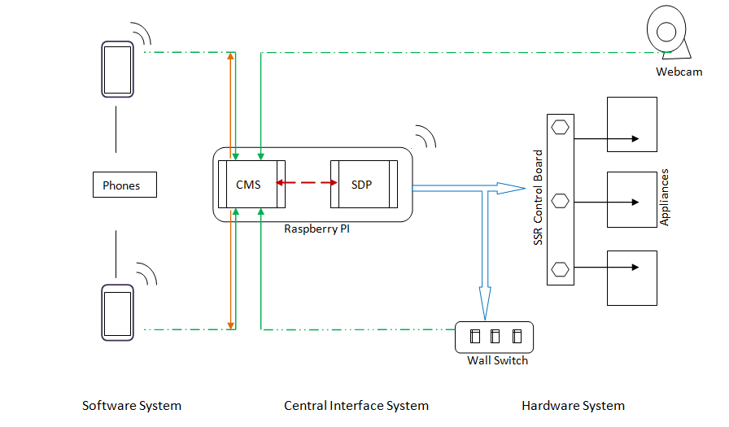

**Structure of the Project**

The project is mainly divided into 3 main structural and functional groups.

**1. Hardware System**

**2. Software System**

**3. Central Interface System [CIS]**

**A. Hardware System:**

The functionality of the hardware system to be reprise the role of actuators that are mechanically and electrically connected to the physical electrical system to provide real time electric power switching and control.

*The main components of the Hardware system are listed below:*

**1. Solid State Relay**

- SSR is one of the most important functional unit. This item is used to control the switching of a AC circuit with a DC trigger circuit. The electrical appliances are wired in series with the SSR.

**2. 7-Segment Display**

- The 7 Segment Display units are used as a visual feedback interface for the end user.

**3. Wall Mount Type Switches**

- These switches provide the functionality of retro fit as well manual control for the home automation system. [*Use Case : When the maid of the house is not authorised to enter the automation network of the house*]

**4. Smart Occupancy Sensor(SOS) - A Webcam**

- A webcam is used as the smart occupancy sensor, where the webcam input is programmed and analysed to detect the presence of a subject of interest [*People in this case*]. The program after analysis sends an appropriate signal with the state of occupancy of the room.

**Non Functional Units:**

**1. Raspberry Pi Extension Board :**

- In order to simplify the connections to and from the Central Interface System, A extension board was designed and used. This board replicates the GPIO pins on the Raspberry Pi for easy and simple connections and routing.

**B. Software System :**

The functionality of the software system is to provide different channels for digital data flow, internet connectivity features and the various business logic written to facilitate the end user in achieving what the project was designed for.

*The main components of the Software system are listed below:*

**1. Synchronous Client Module [SCM] - A Mobile Application on Android Platform**

- A mobile application forms the most crucial unit of the software system. The phone acts as the remote which has the application that provides the user an intuitive, simple and clever user interface to enhance user experience and provide complete information of the system.

**2. SmartSense – Webcam Analysis Program**

- The SmartSense is the program that complements the SOS hardware unit. This program is used to detect the presence or absence of people from the frame of the camera. This program is extensible to detect any subject of interest.

**C. Central Interface System [CIS] :**

The CIS module is a combination of Hardware and Software functionalities that facilitates flawless and easy integration of the Hardware and Software structures of the project. CIS is the encapsulating mechanism for Raspberry PI, SDP and CMS.

*The main components of the CIS are listed below :*

**1. Raspberry Pi [RPI]**

- A Raspberry Pi is a credit card sized advanced microprocessor with various ports and programmable GPIO headers. The RPI is powered by a Debian OS called Debian Wheezy. The RPI is capable of executing programs written in different languages and also provide internet connectivity.

**2. Server-Driver Program [SDP]**

- The server driver program is the program that interacts with the hardware of the Raspberry Pi to produce various control signals on the GPIO headers. The Server Driver Program runs as Server to the Content Management System (CMS) module. This program is responsible for the actual triggering of hardware interfaces.

**3. Content Management module [CMS ]**

- The CMS module handles all the different incoming connections from different interfaces like Digital Switch, Android Apps [*support for multiple instances of the App on different phone, is provided*], and extensible to web control and further more. The CMS module has been designed using active threading concepts and uses parallel threading functionalities along with the dual role of being a client to SDP and a server to SCM and SmartSense.

*Salient Features of the Project*

1. *The remote for the automation system is a phone which is now a part and parcel of every individual.*
2. *Proposes architecture for retro fit capabilities with minimal changes.*
3. *Any number of phones can be used to connect to the same house and all the phones will be in complete synchronization with each other and also with the digitally wired physical switches.*
4. *The app also provides options to activate/deactivate SmartSense Occupancy control.*
5. *The data collected from the switching of appliances can be aggregated to produce reports on total usage of individual equipments as well as for individual rooms.*
6. *Concepts of Auto-switch off, Timer Setting, Warning alarms are integrated into the mobile application.*
7. *The in-house kWH manager provides data of the usage of electric power.*
8. *This project can be integrated to Smart Grid Systems in future.*